# CS 255 System Design Document Template

This template lays out all the different sections that you need to complete for Project Two. Each section has guidance to prompt your thinking. You will need to continually reference the interview transcript as you work to make sure that you are addressing your client’s needs. There is no required length for the final document. Instead the goal is to complete each section based on what your client’s needs are. Remove this note when you are finished, and replace all bracketed text with the relevant information.

## UML Diagrams

### UML Use Case Diagram

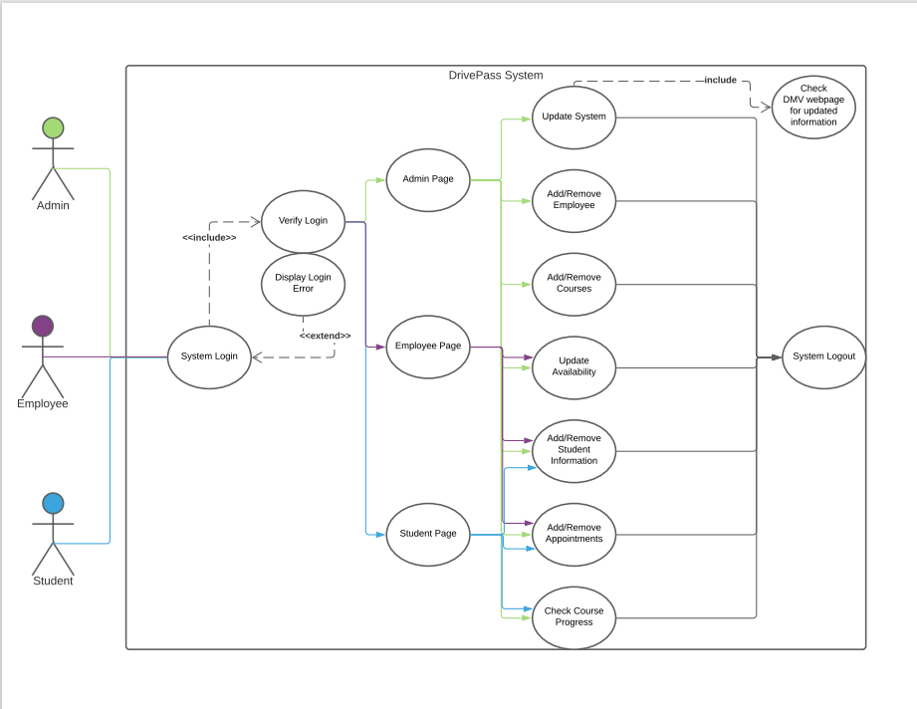

### UML Activity Diagrams

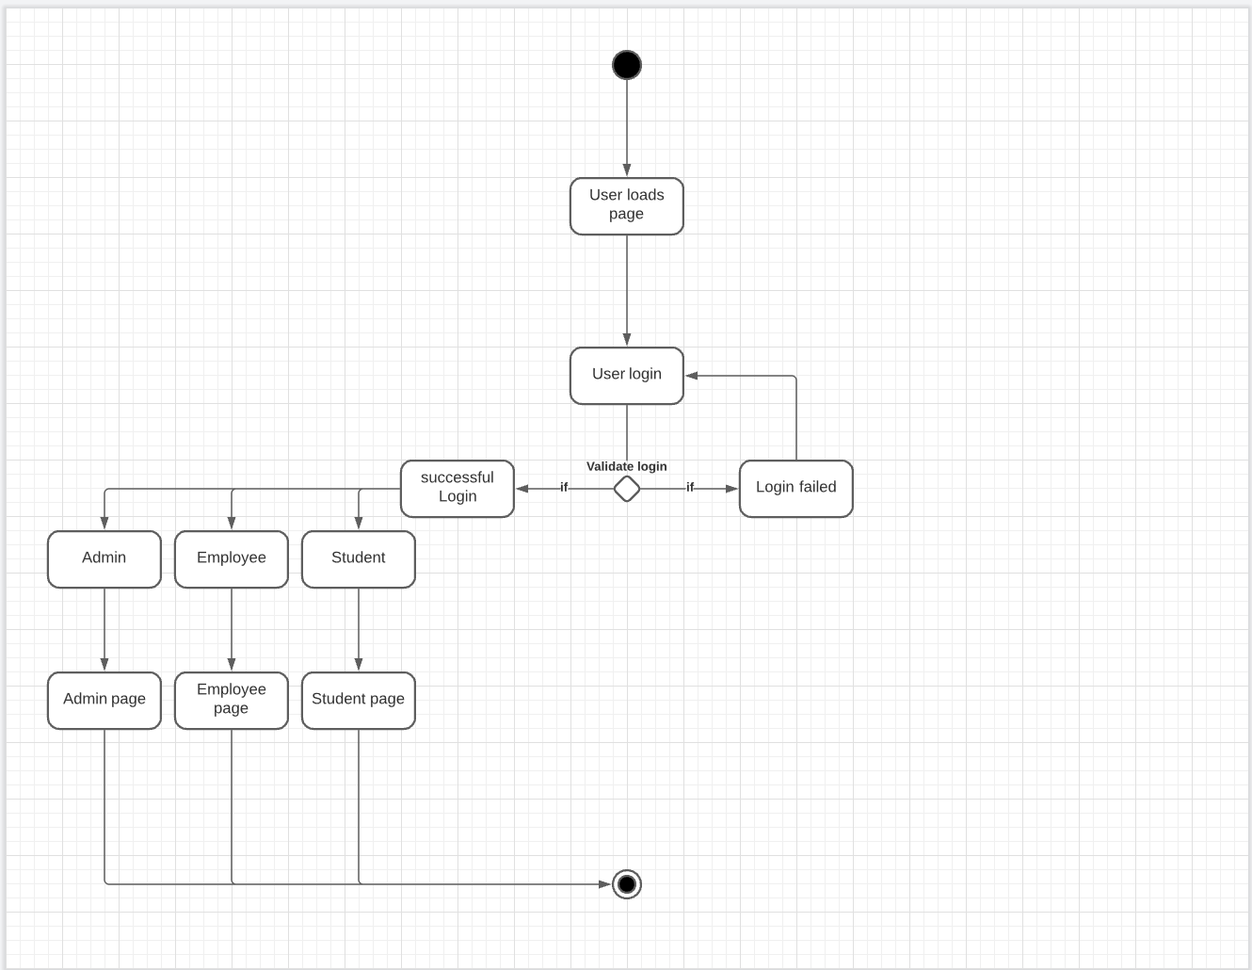

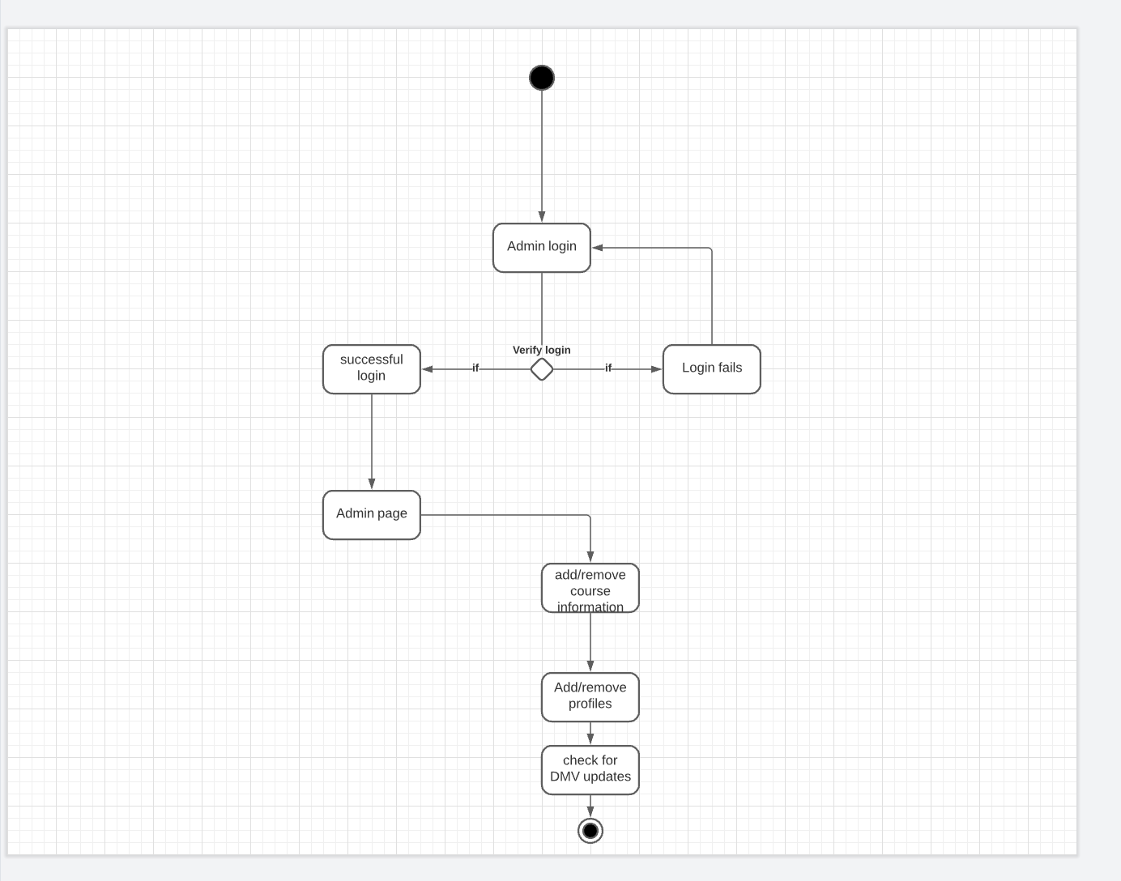

### UML Sequence Diagram

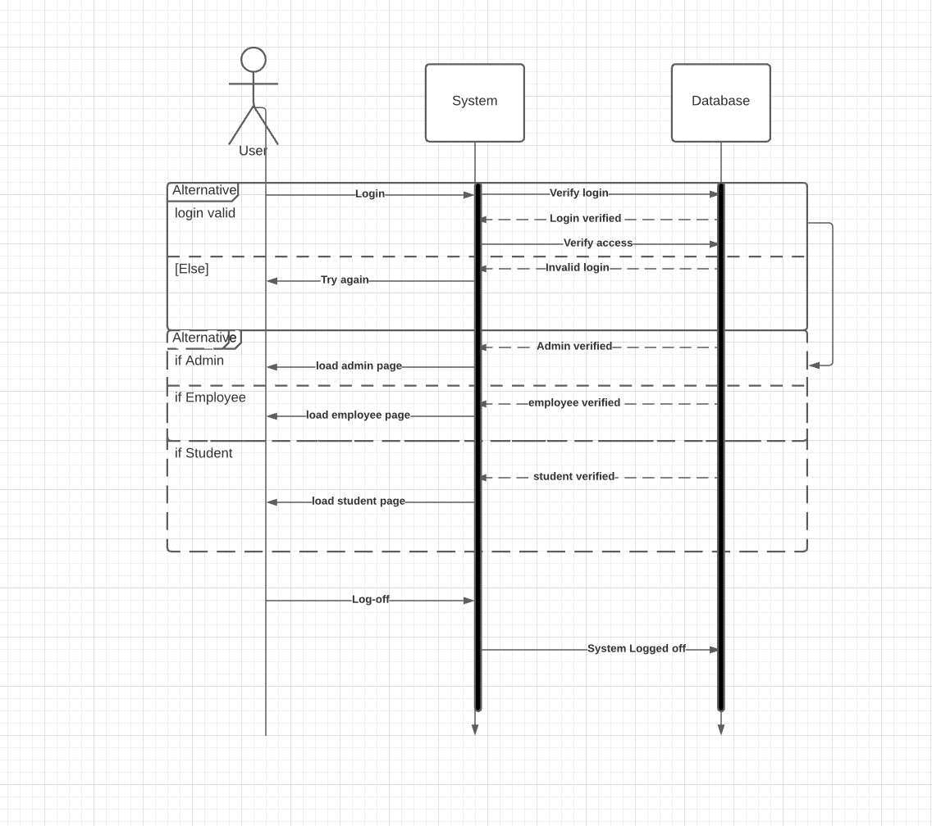

### UML Class Diagram

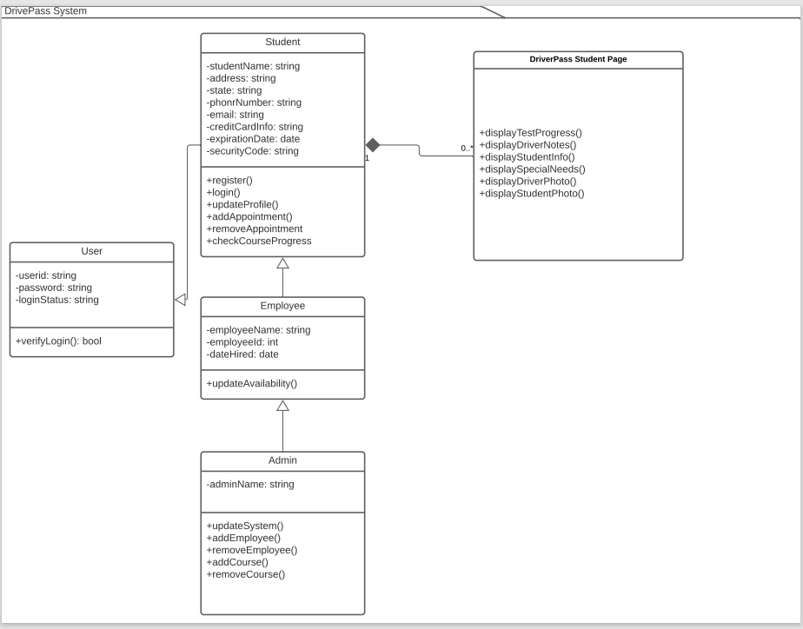

## Technical Requirements

First, we need the cloud service so we can store all this information. Which starting out there are some free options that we can use until we are ready to pay for the upgraded services. We will set up the different users for the system, the student, the employee’s, and the Admin. Once this is done, we will need to train people on how to use the system. When we launch the system, I would recommend that we wait on the mobile version until we have had a chance to get the bugs out of the system and then when we have a bigger customer base, we can launch the mobile version.